**Hosting https static Website using**

* S3
* Route 53
* Aws Certificate Manager
* Cloud Front

In Route 53 register Domain for as low as 12 $ only (*recommended)

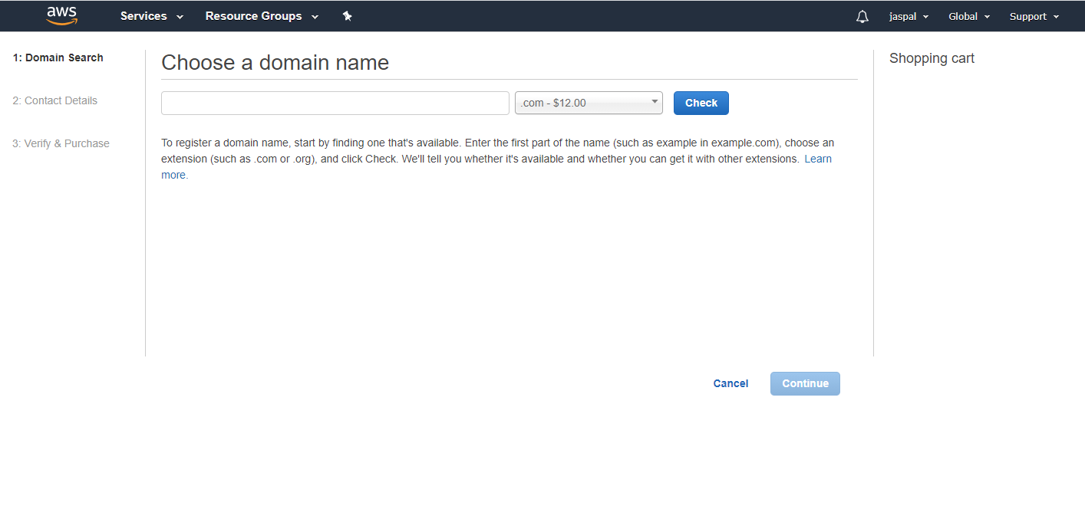

We can use other domain provider also but it will take 3-7 days to be transferred to aws.

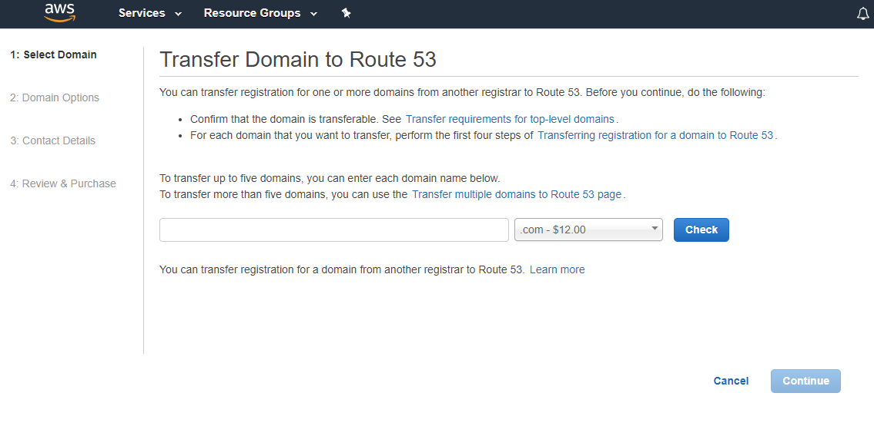

Once registration done we can see under Registered Domains

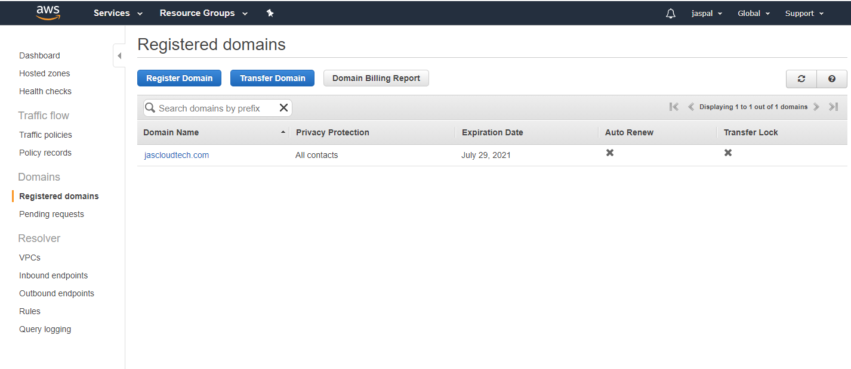

Now move on to S3

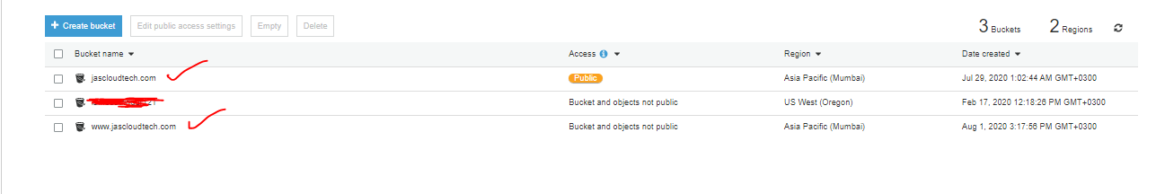

We will create two buckets

xyz.com

[www.xyz.com](http://www.xyz.com)

Copy all the contents (html,css…) in the first bucket xyz.com

Enable Static Website Hosting under **Properties and define the default page**

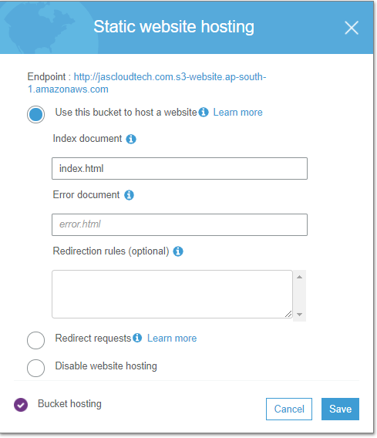

Under **permissions** got to **Bucket Policy** and add

{

"Version": "2012-10-17",

"Statement": [

{

"Sid": "AddPerm",

"Effect": "Allow",

"Principal": "*",

"Action": "s3:GetObject",

"Resource": "arn:aws:s3:::xyz.com/*"

}

]

}

Now we will map our buckets in Route 53 click on the hosted zone

And then create record

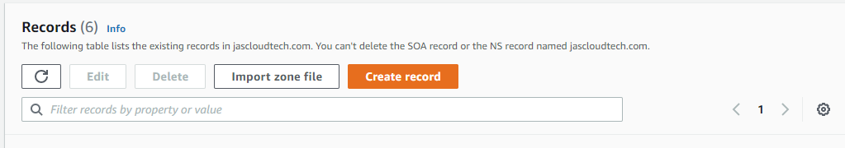

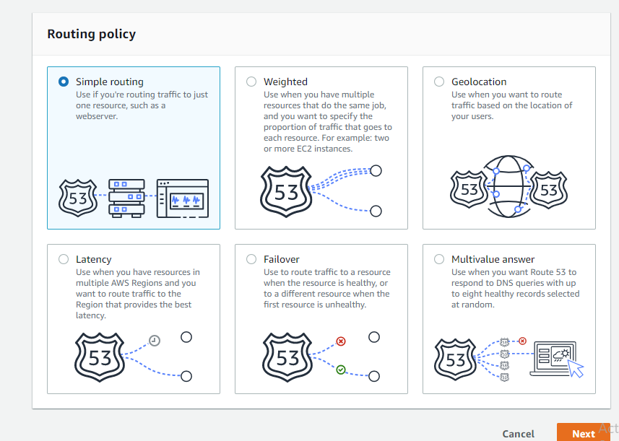

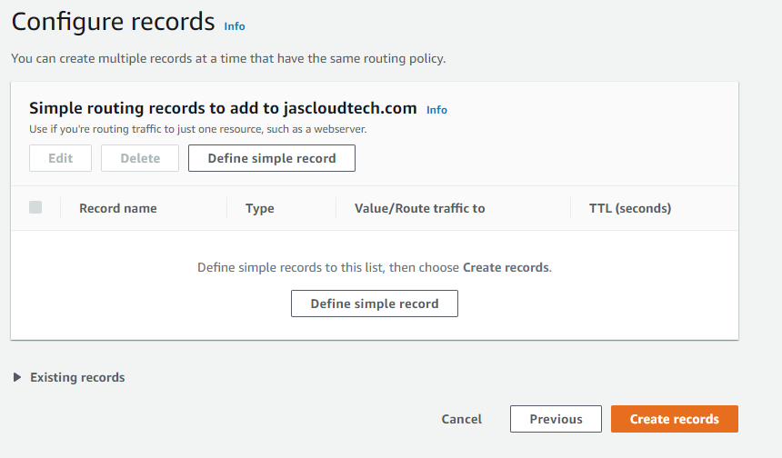

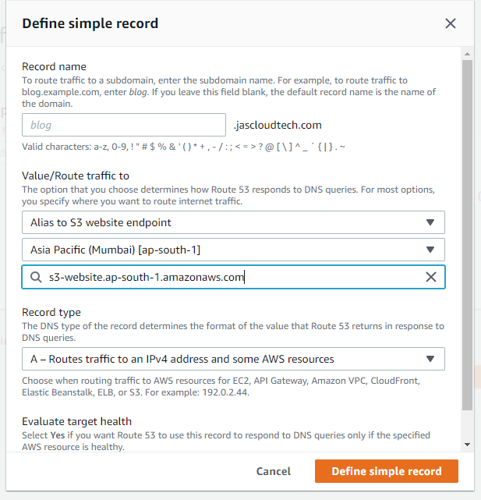

Similarly, for [www.xyz.com](http://www.xyz.com) and choose the corresponding bucket

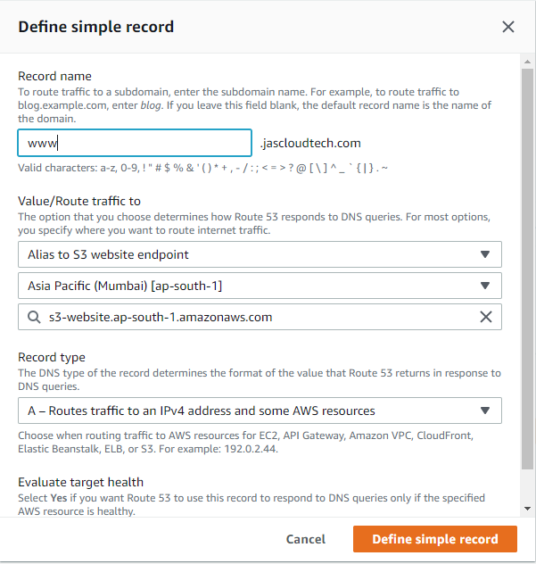

We can check our url both are working now

In the next step we will move to ACM-aws certificate manager